**Static Web Host on Public DNS**

**avsivaranjan.live**

**Step 1: Create S3 bucket & object and their settings. Given Below**

**Step 2: Create R53 Hosted Zone . Setting given below**

**Step 3: Name nameserver from our DNS.**

**Step 4: Generate ACM SSL certificate in N. Virginia . Settings given below**

**Step 5: Create CloudFront Distribution and Settings Given below.**

**Step 6: Create Record in R53 and add alias from CF & Distribution Name.**

**That’s it Hurray**

**Output (https://avsivaranjan.live)**

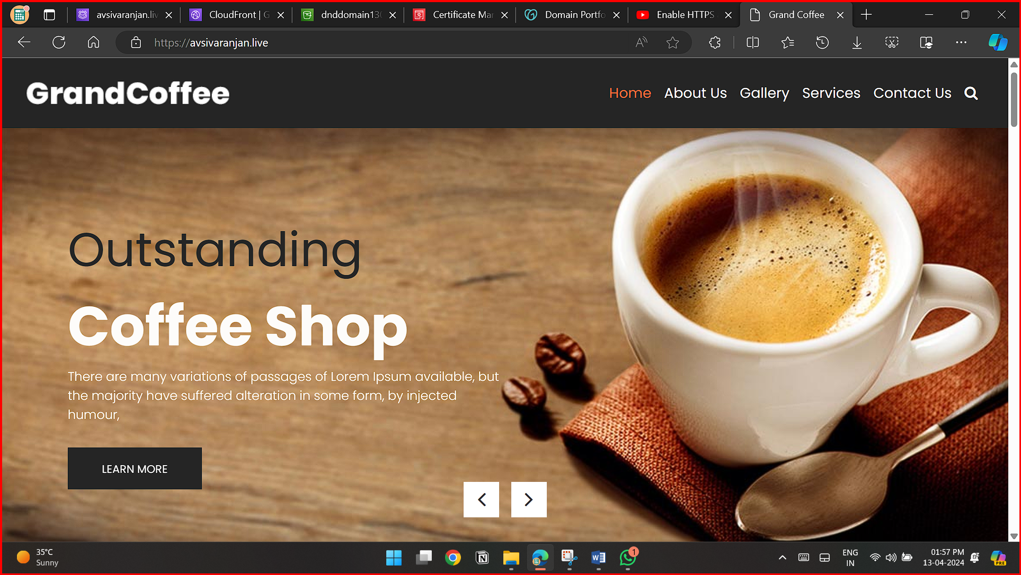

**S3**

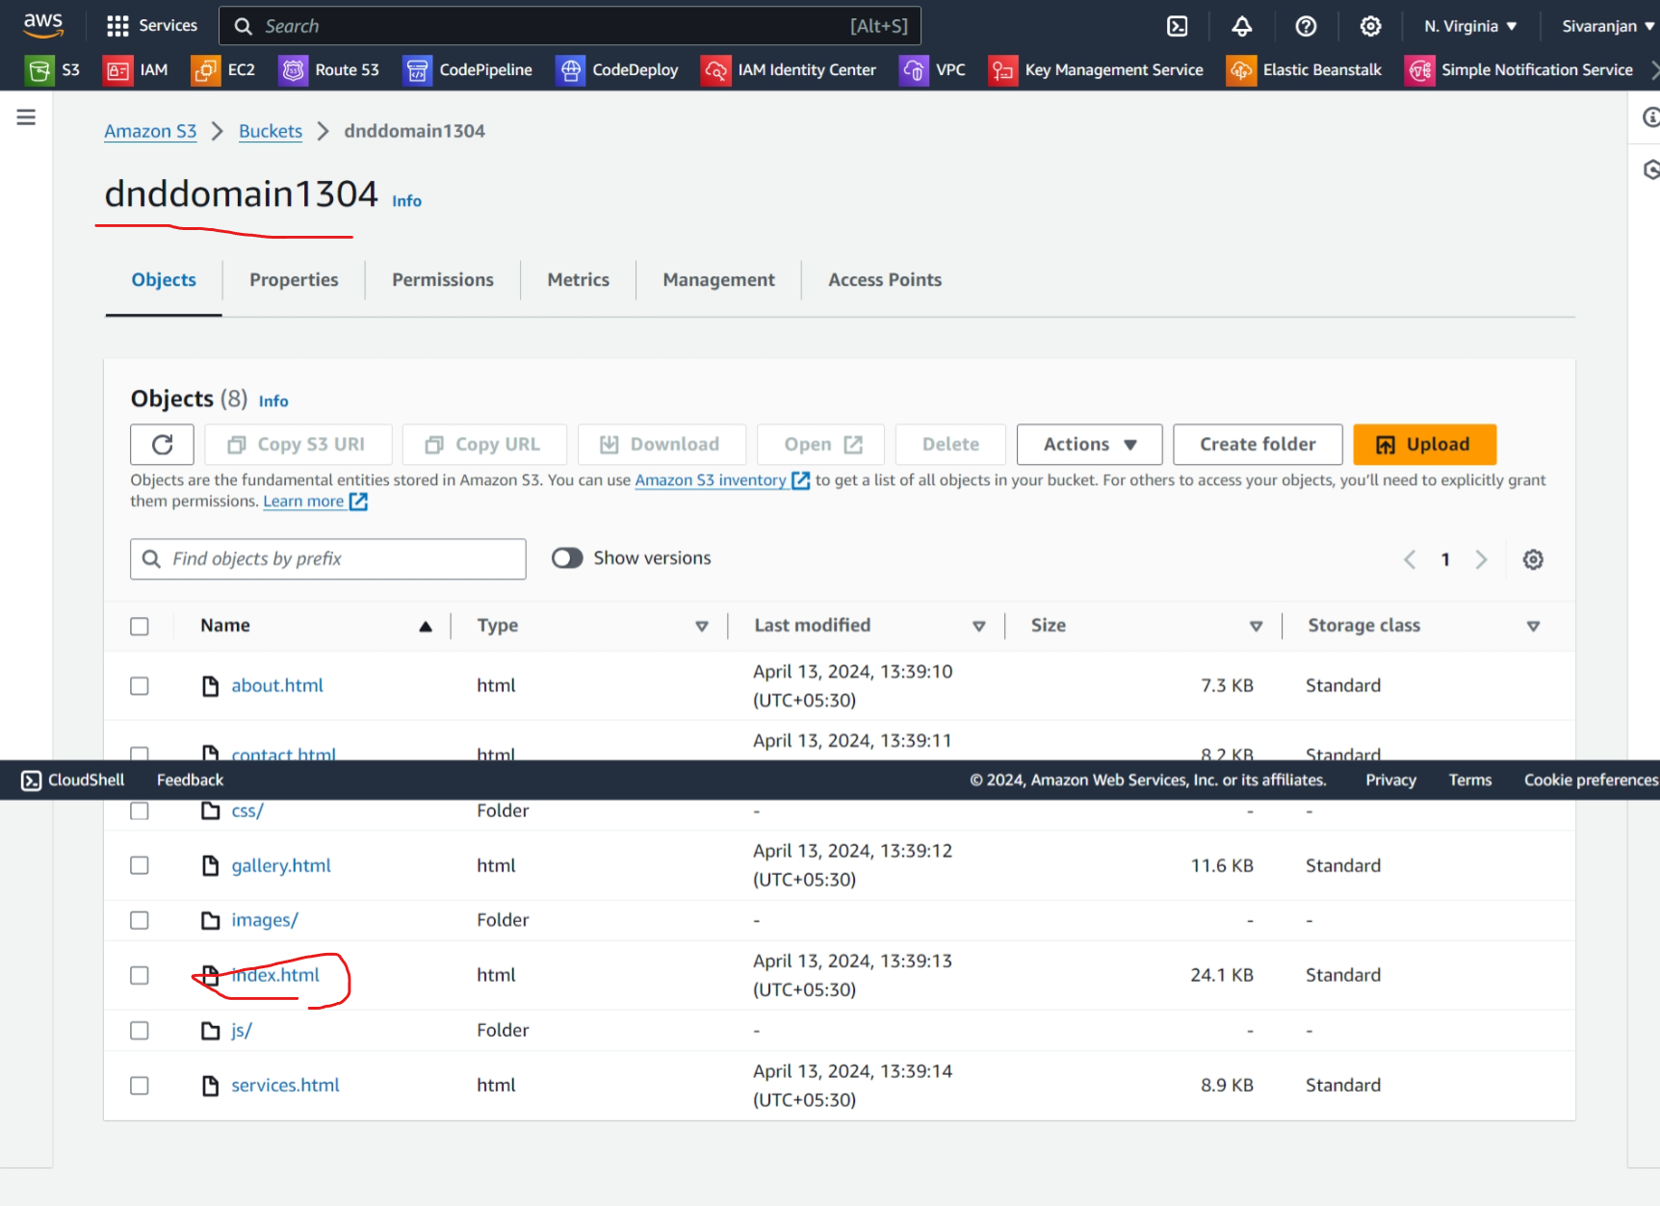

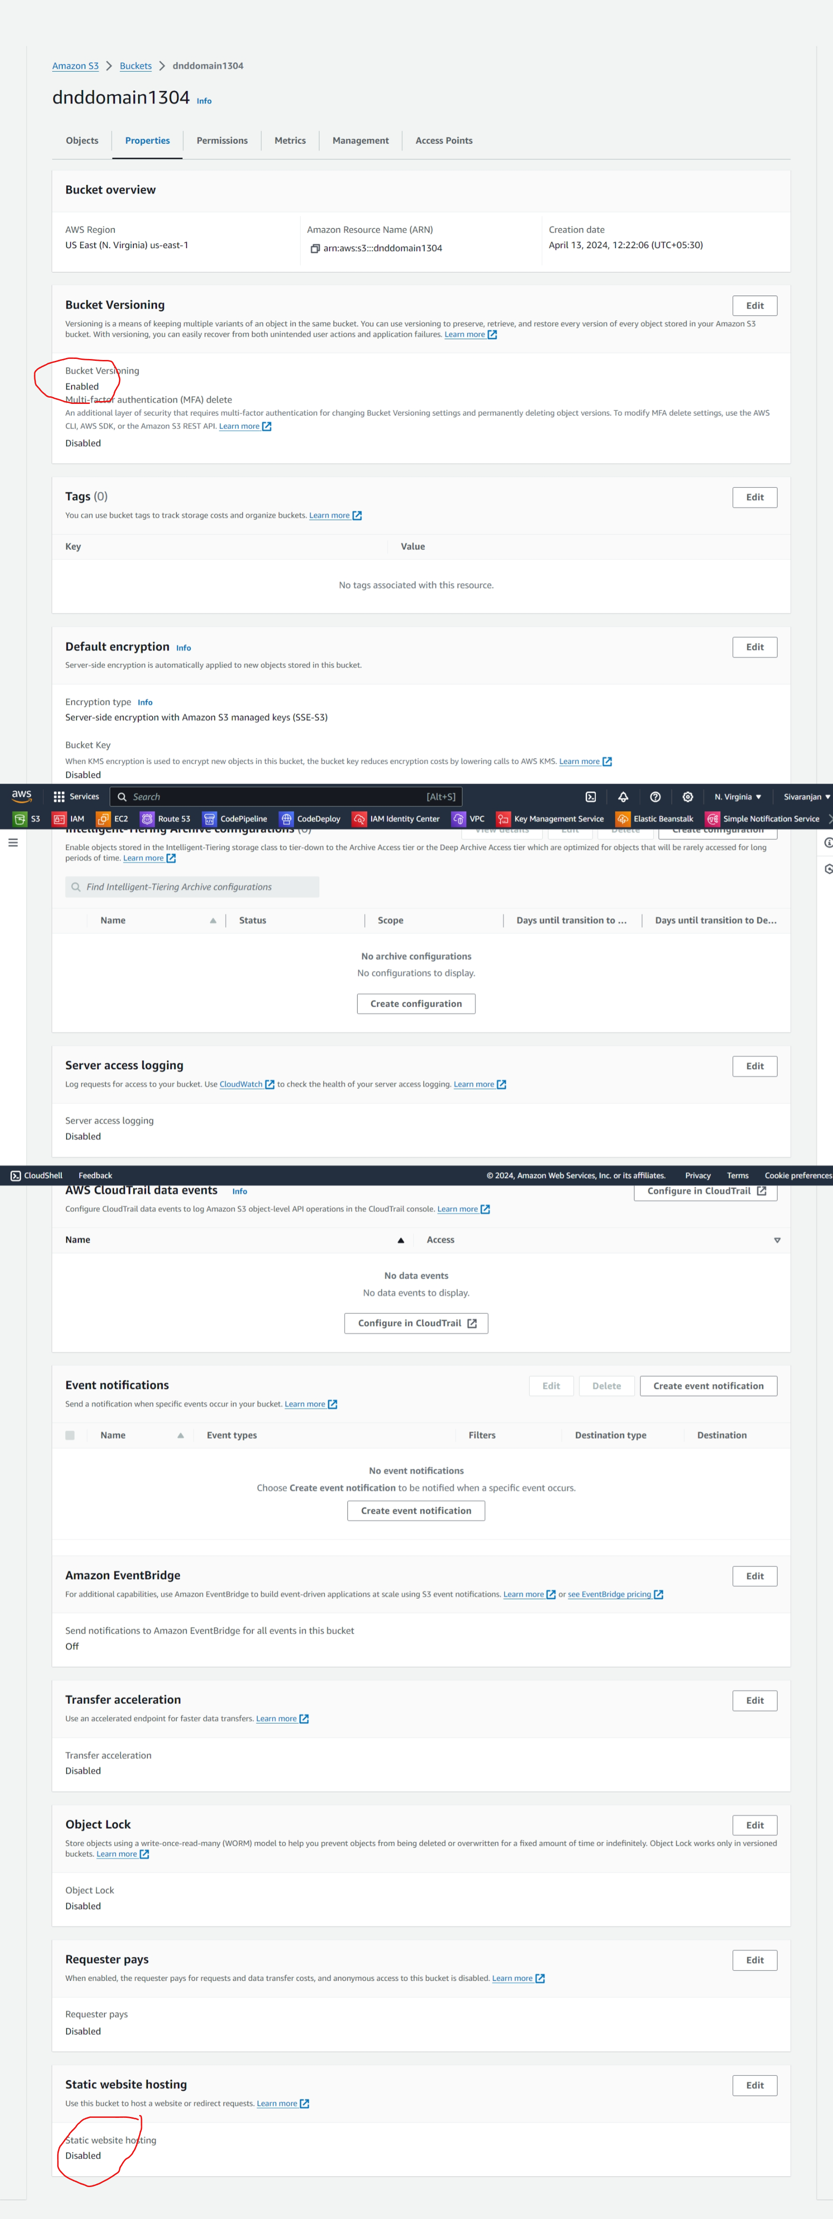

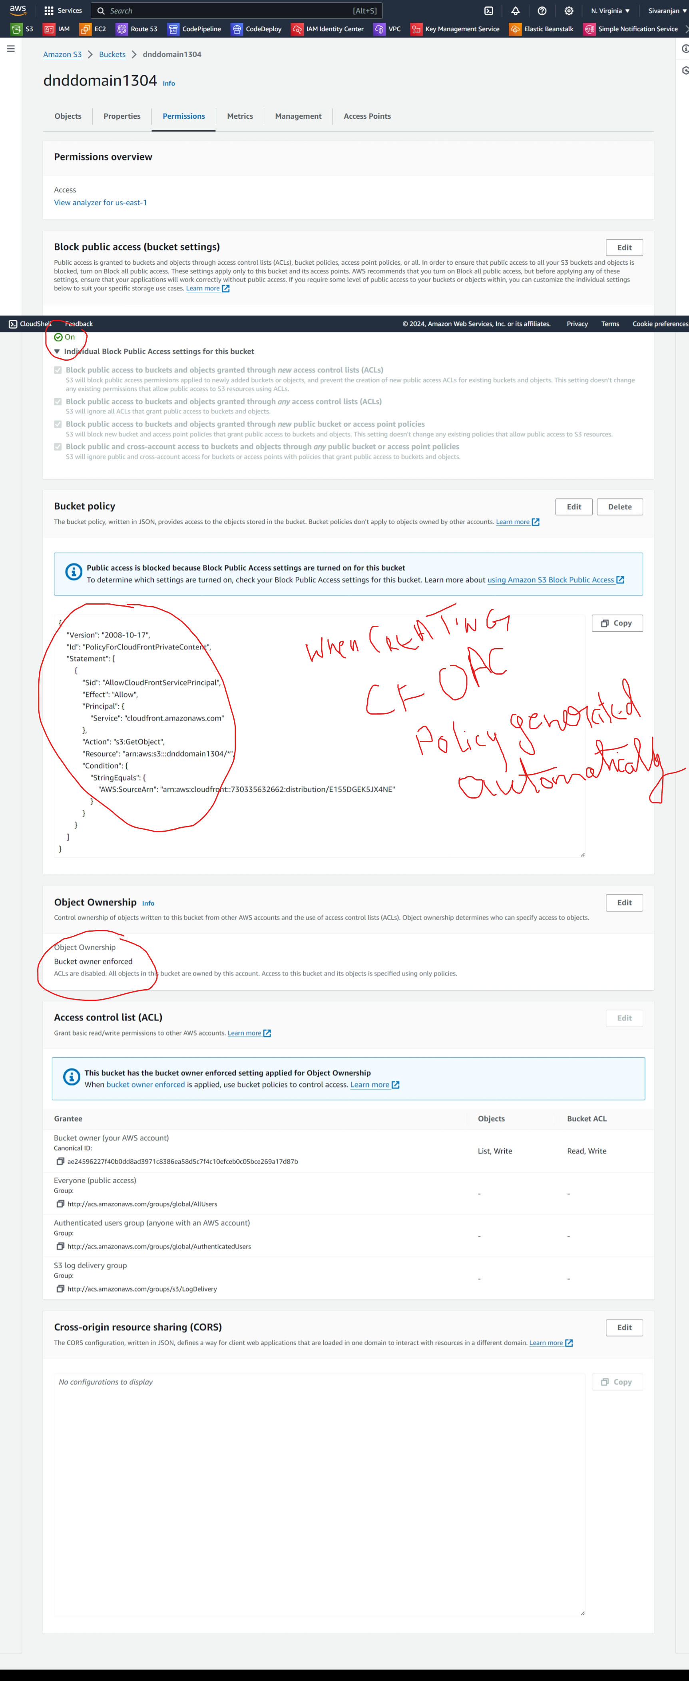

**ACM**

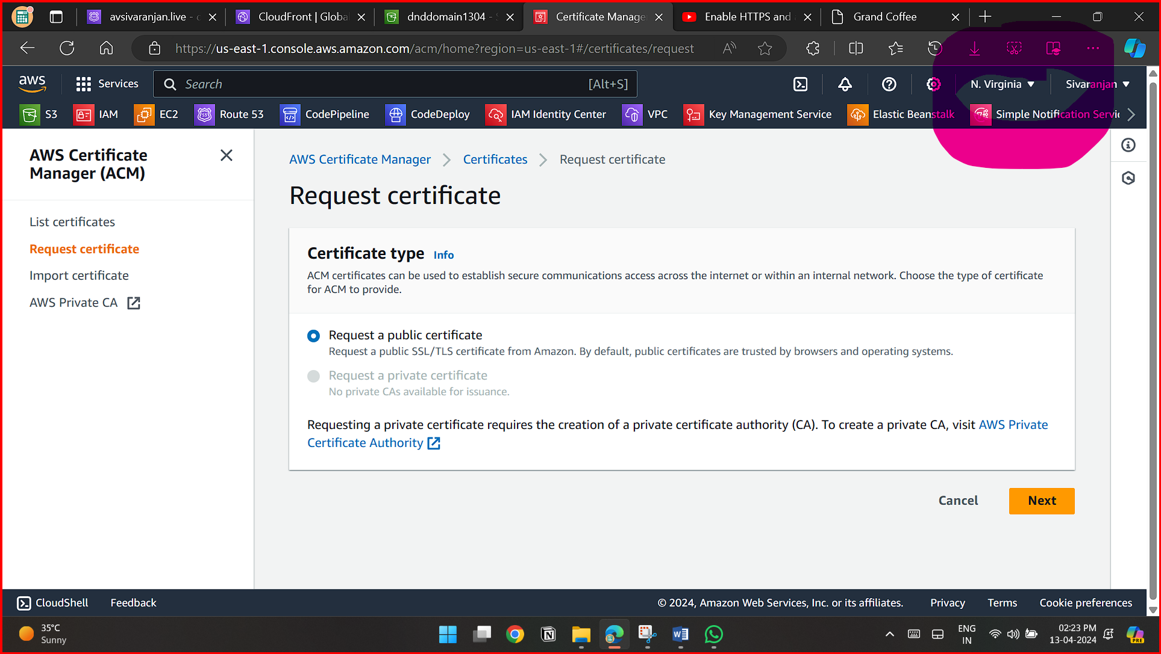

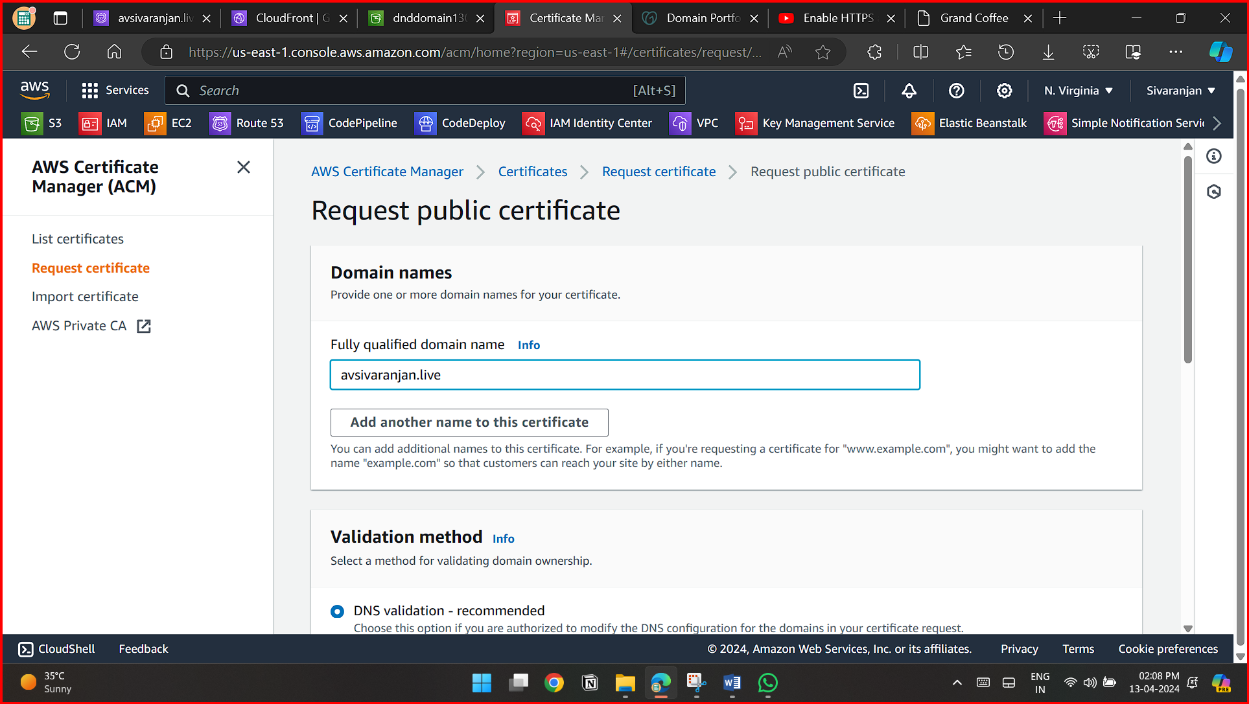

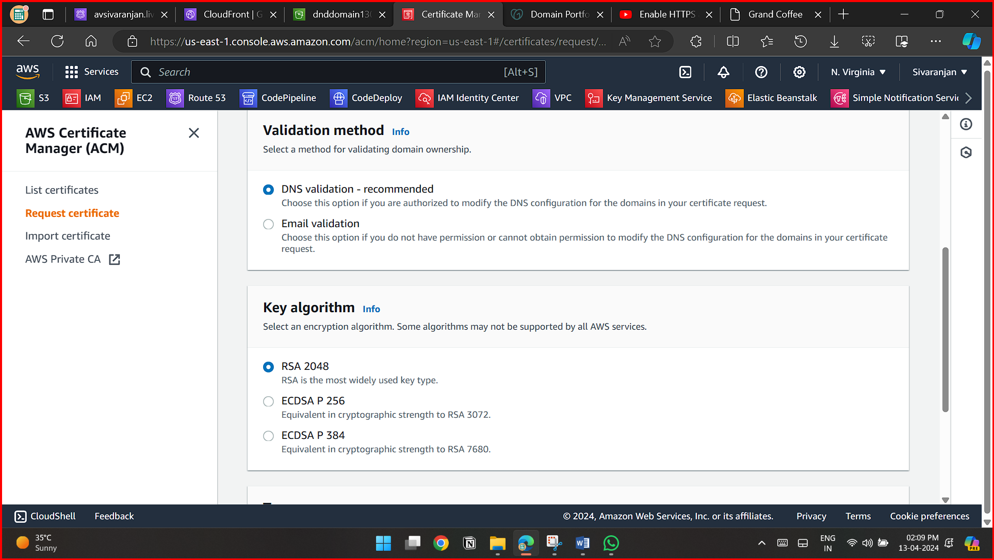

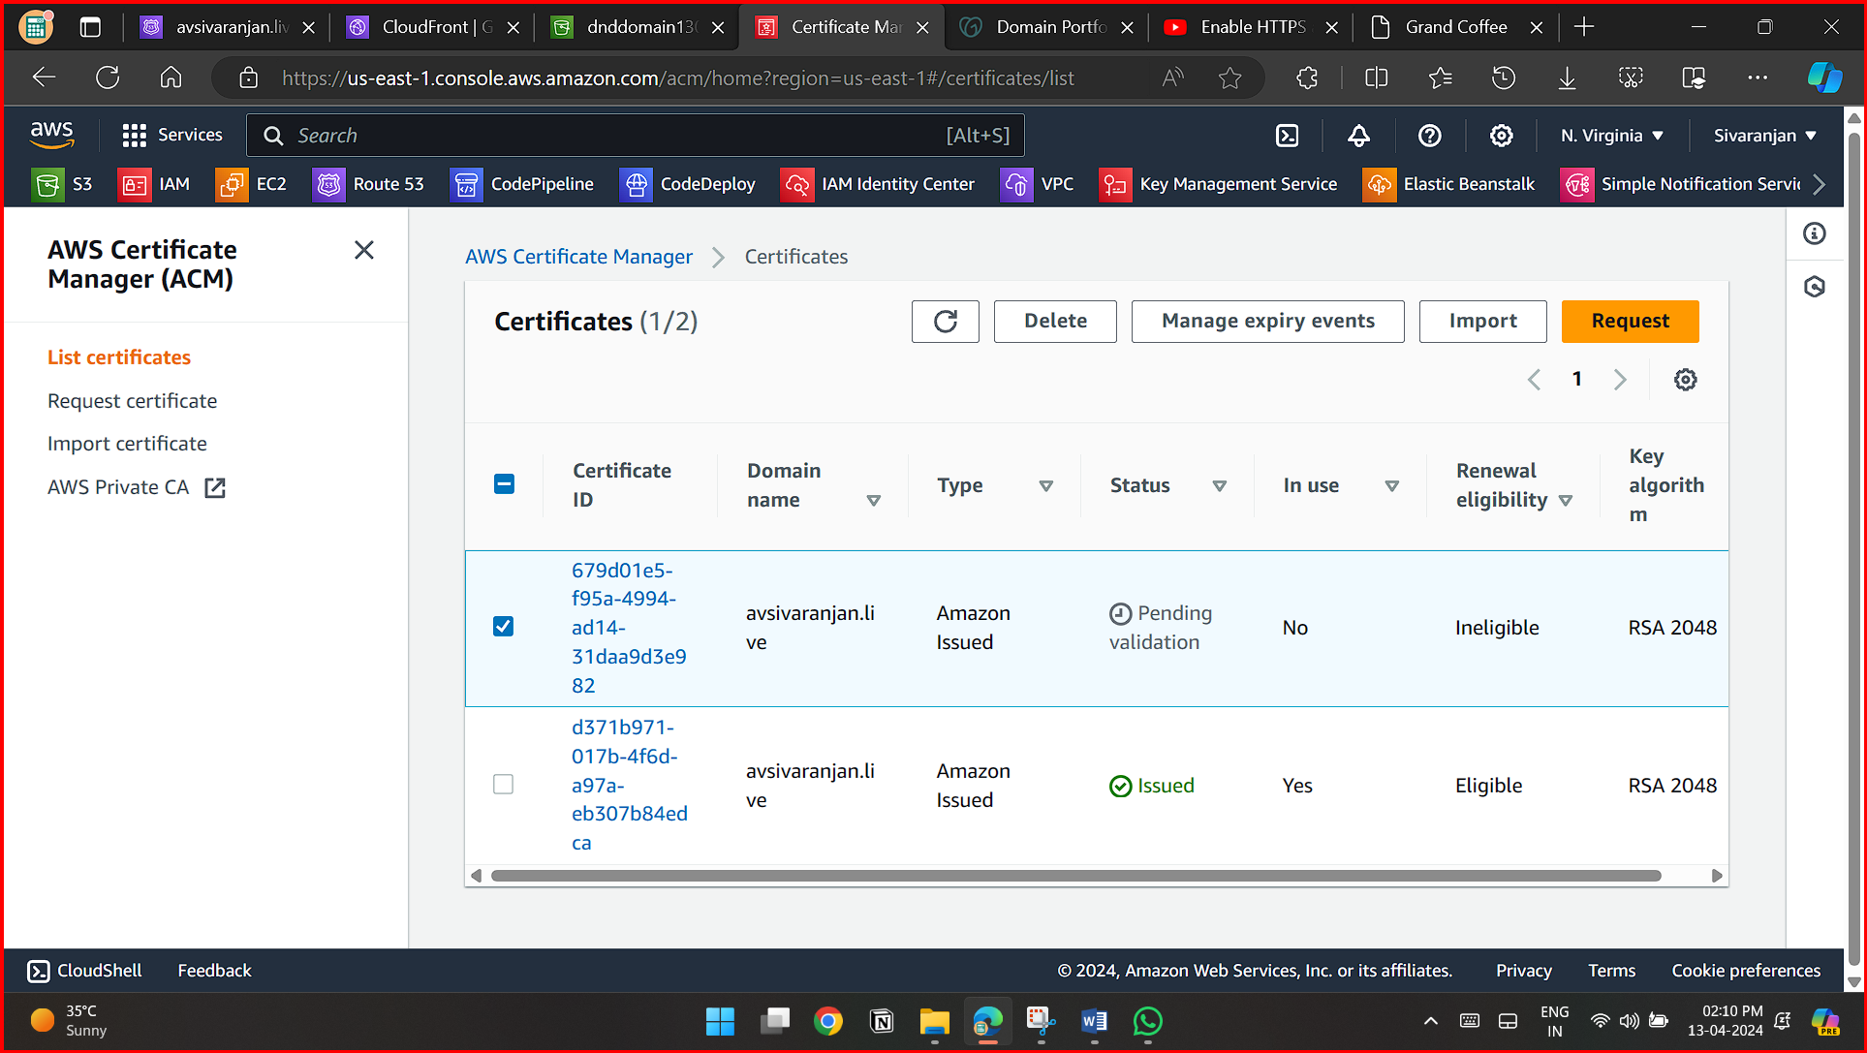

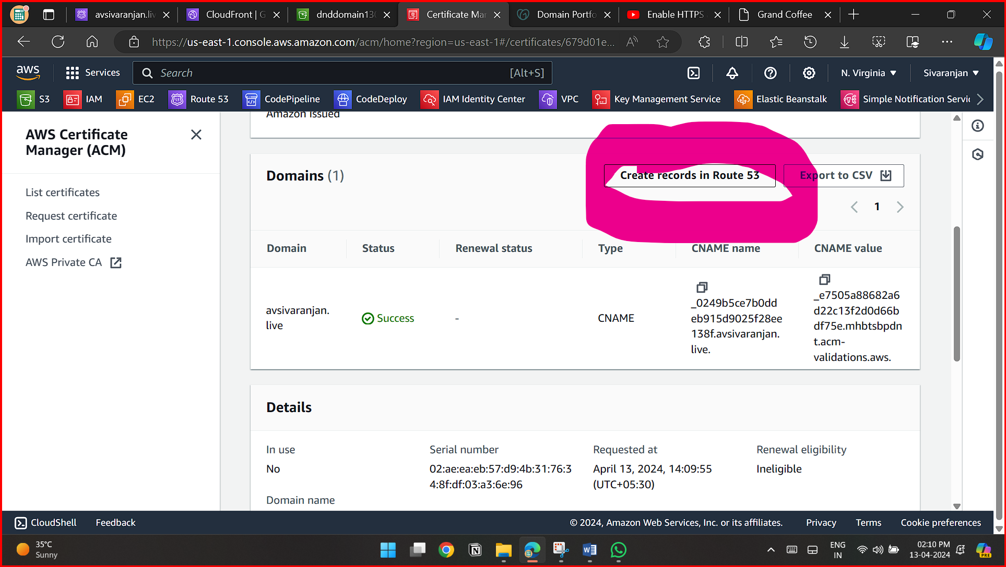

**ROUTE-53**

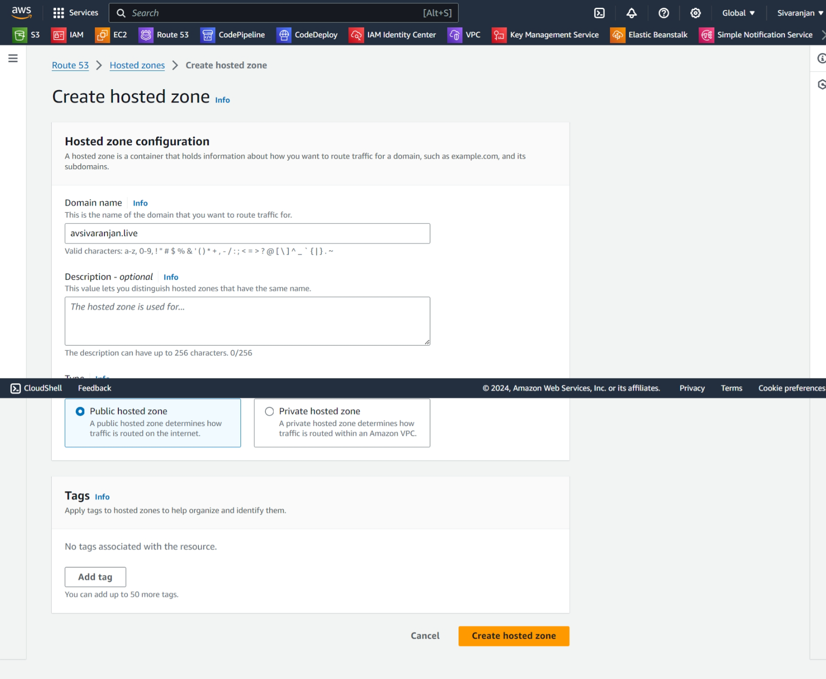

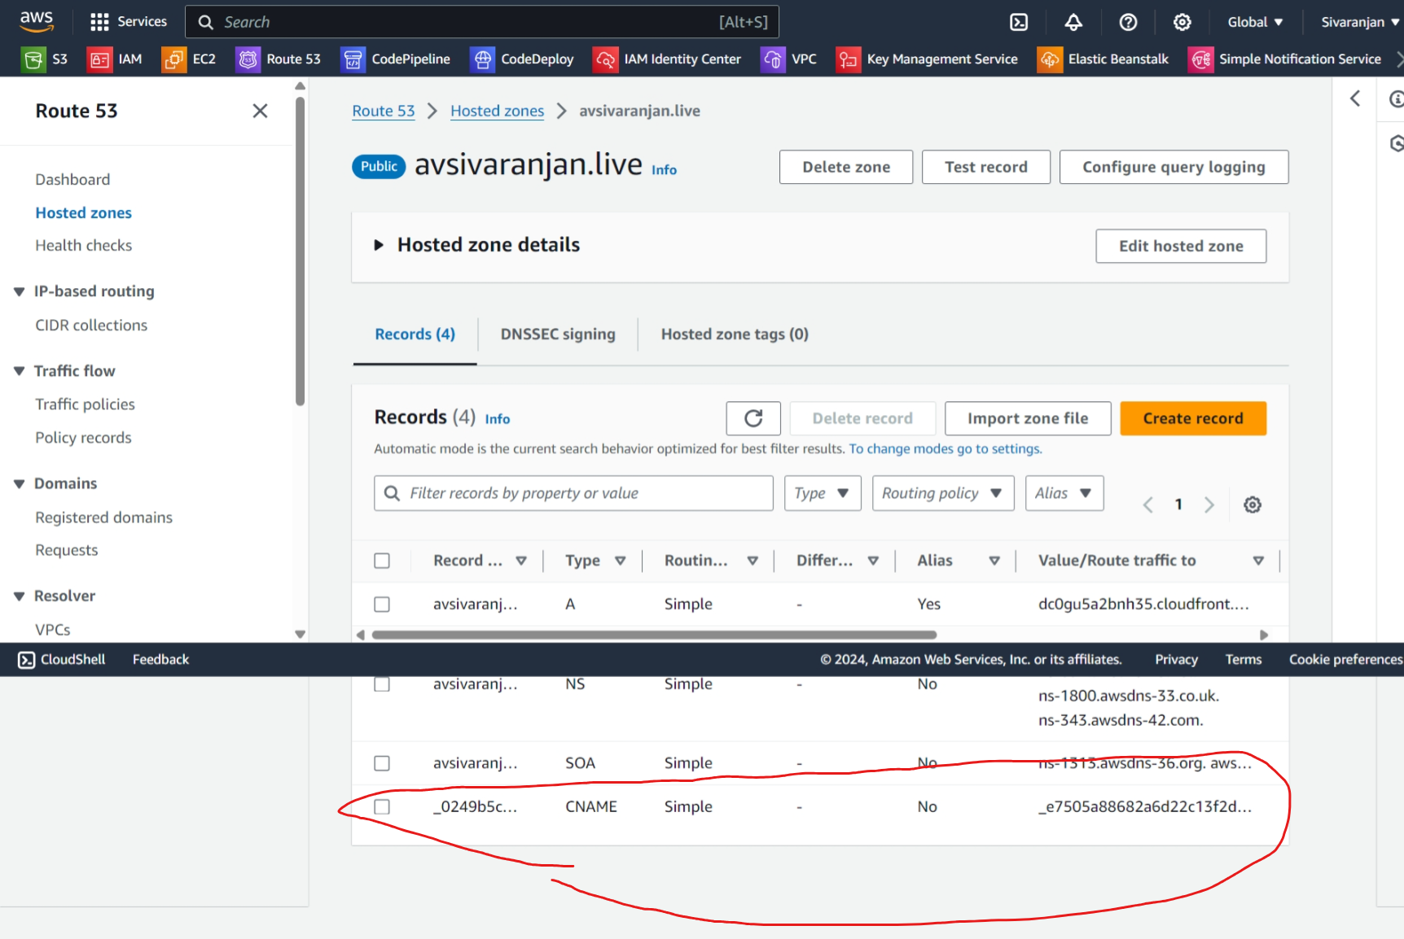

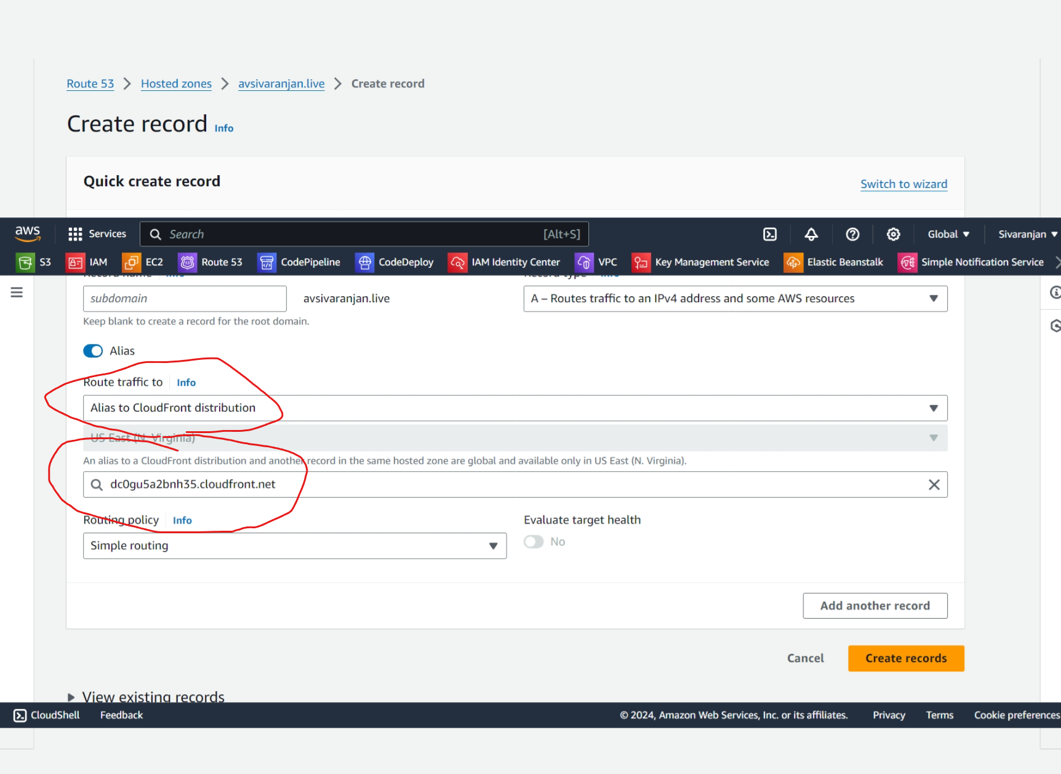

**DO-DADDY**

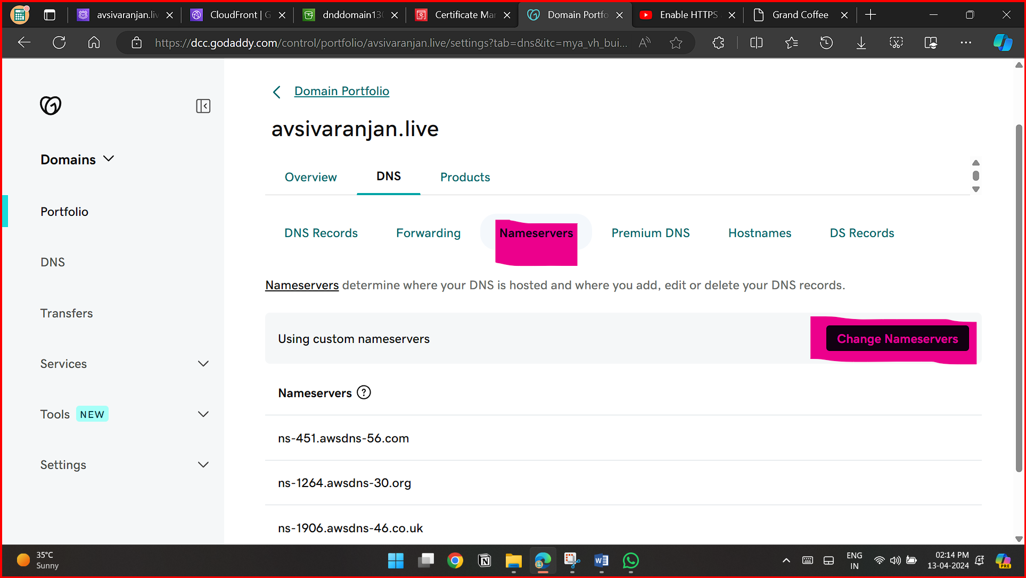

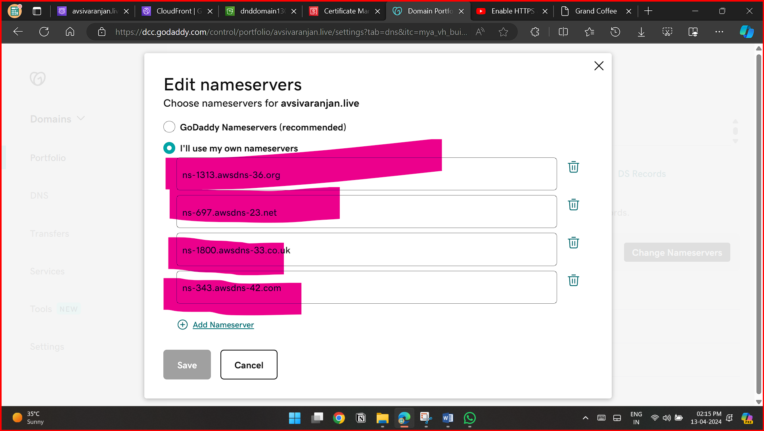

**CLOUD-FRONT**

**Settings:**

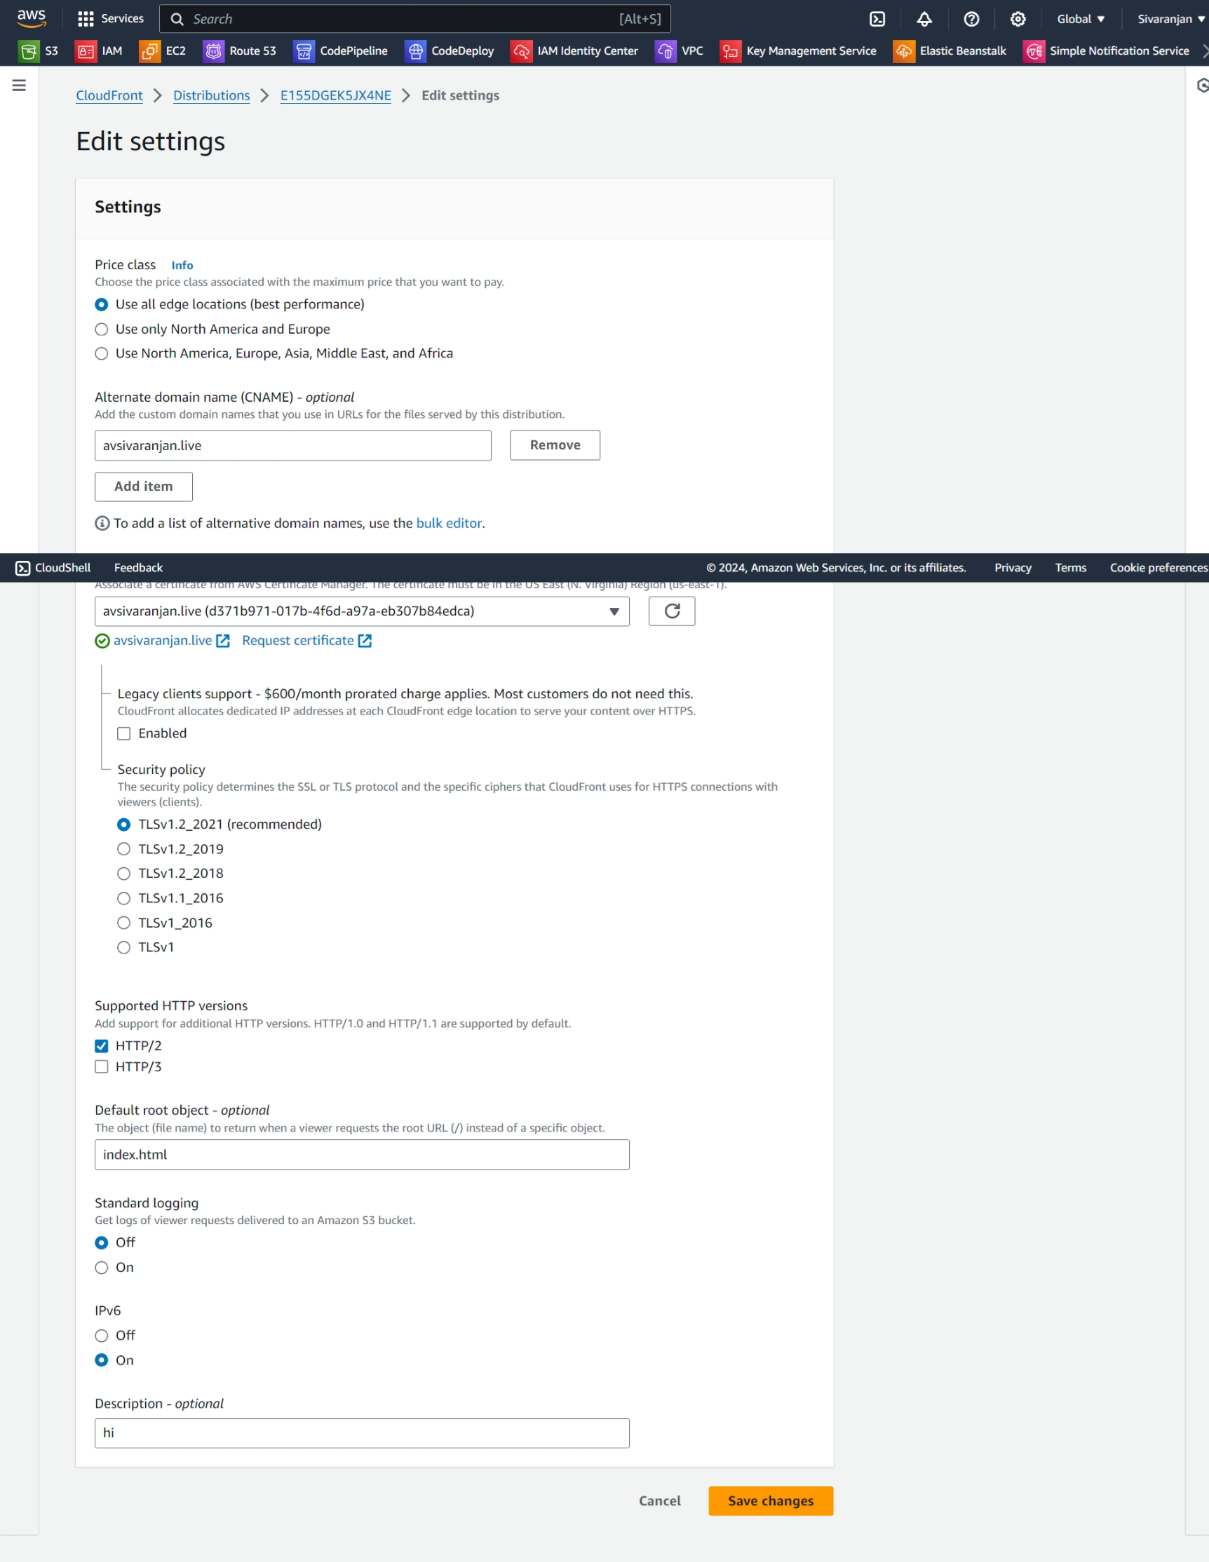

**Origin:**

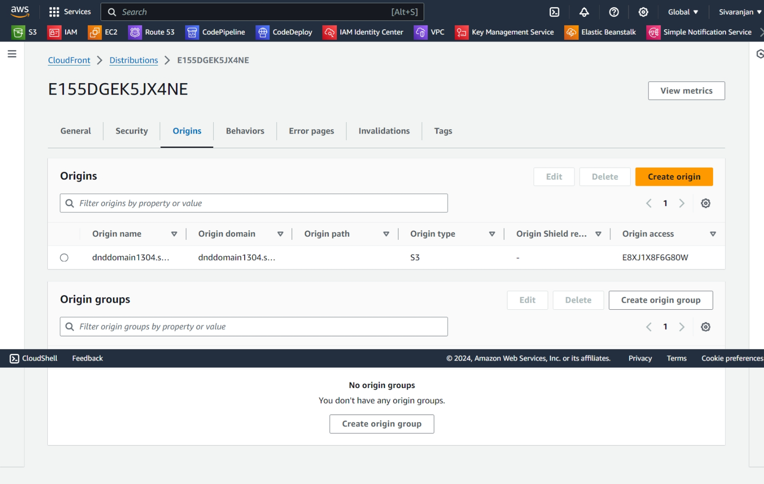

**Origin Settings:**

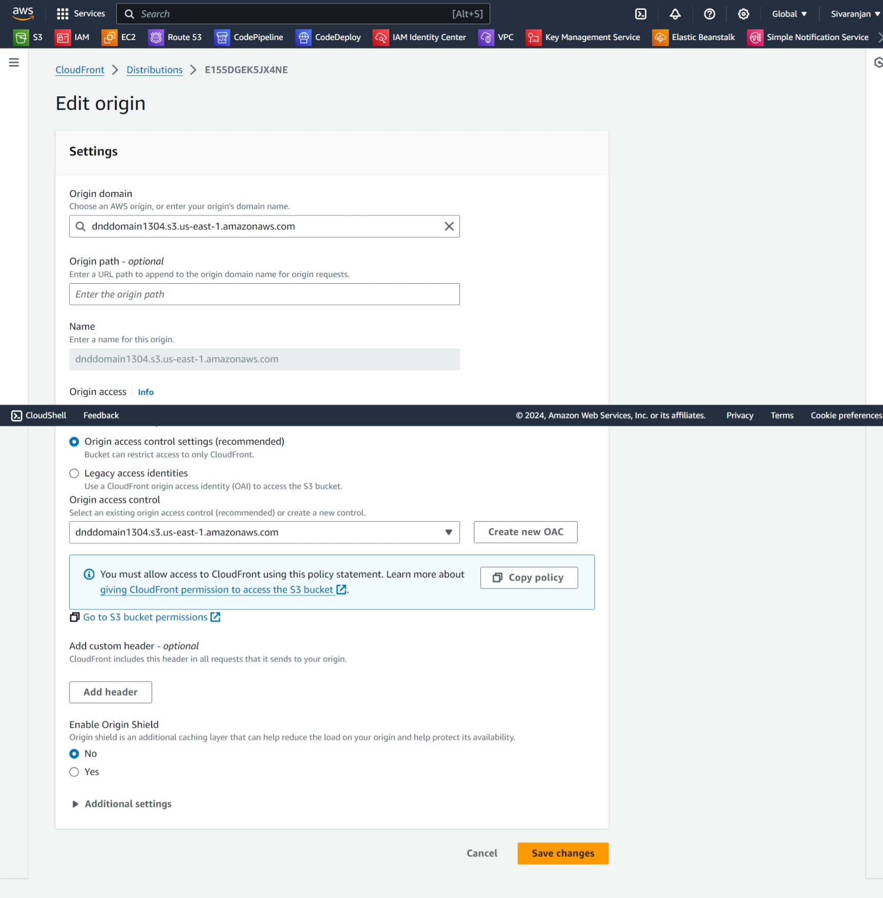

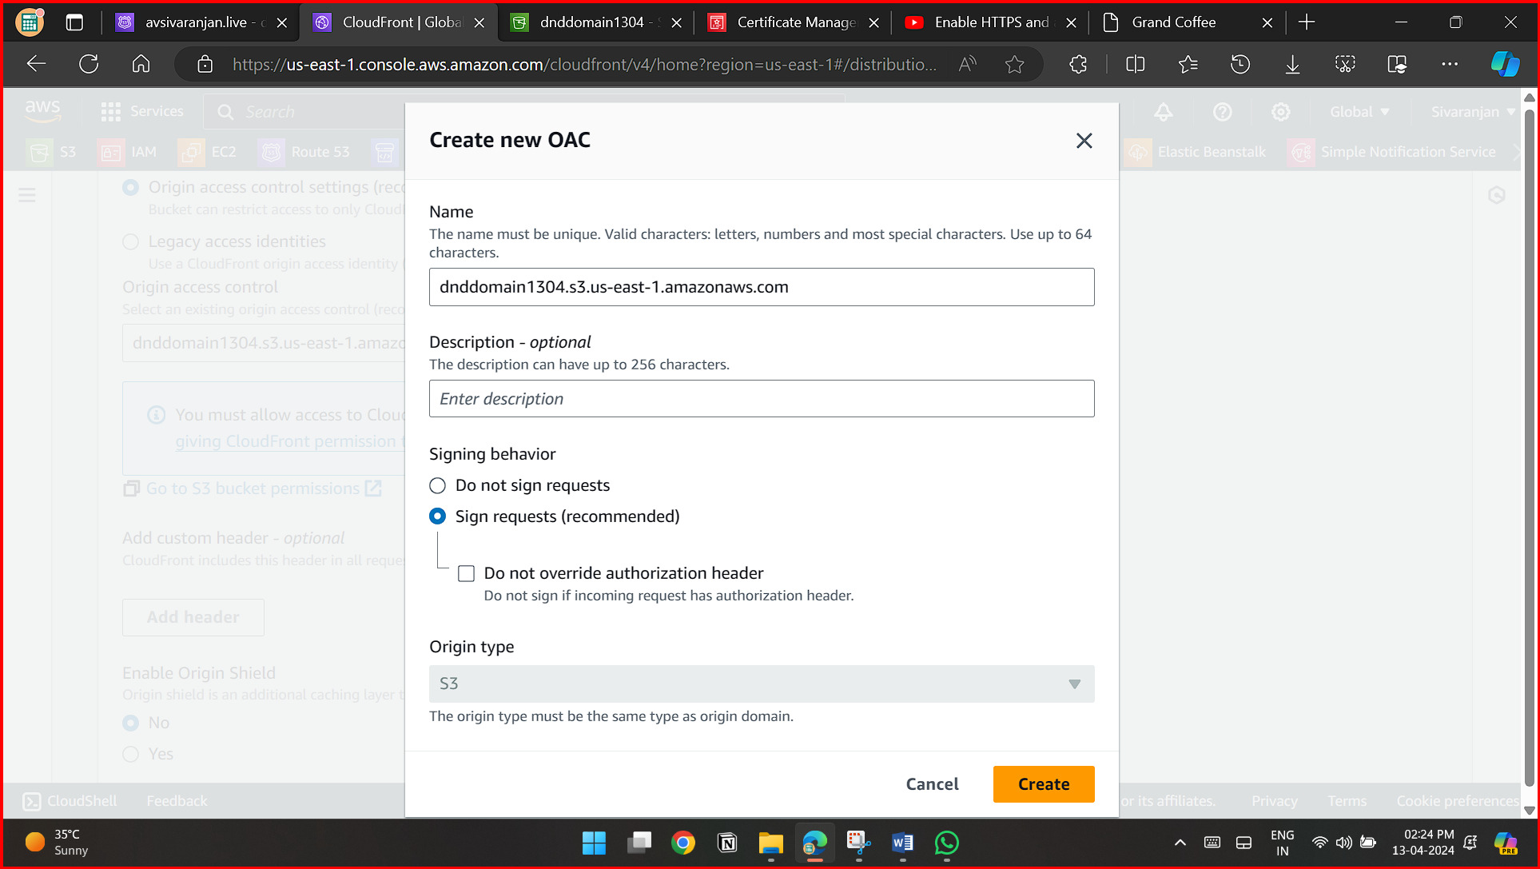

**Behavior Settings:**

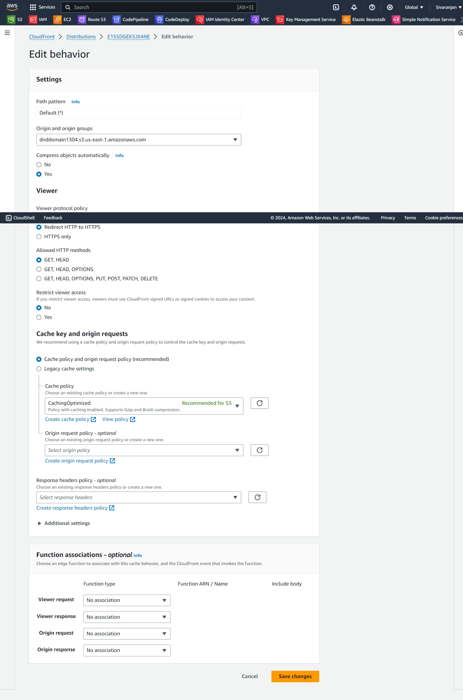

**OUTPUT:**



